**Gen. AI**

* There are total two perspective of genAI first is builder’s perspective means those who builds models from scratch and second is User’s perspective means those who use model,LLM using different tools.
* Below image shows both perspective and their respectfull roadmap of learning it.

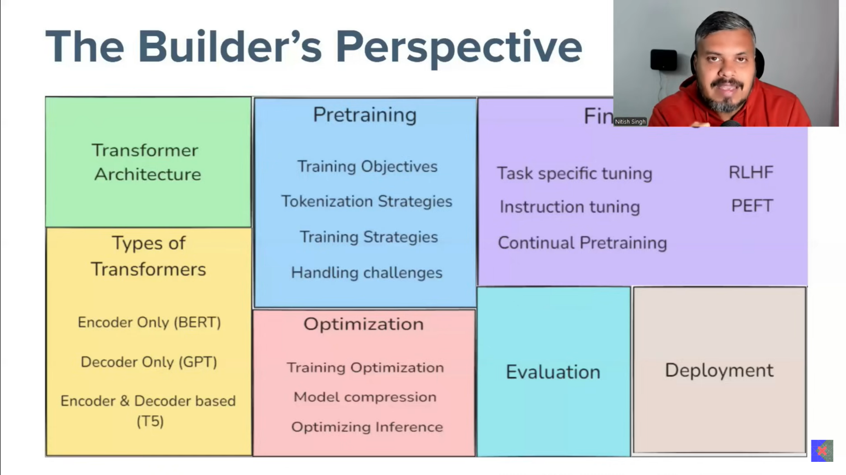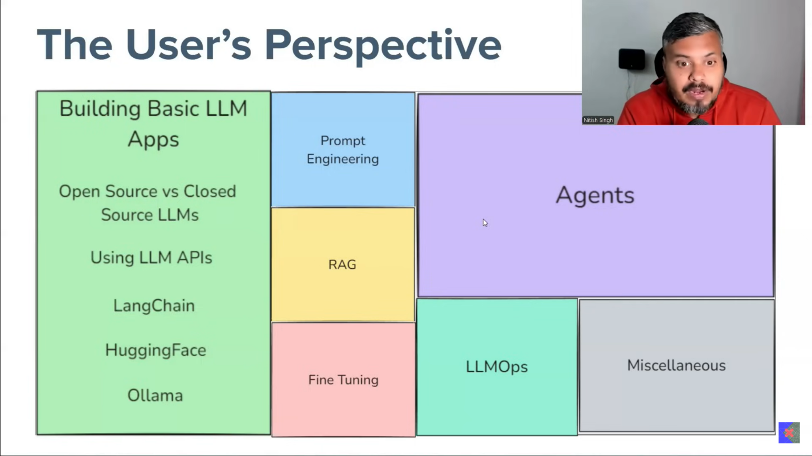

* We will start our learning from User’s perspective, in that we will start from langchain.

**Langchain Roadmap**

1. Fundamentals
   1. What is LangChain
   2. LangChain Components
   3. Models
   4. Prompts
   5. Parsing Output
   6. Runnable & LCEL
   7. Chains
   8. Memory
2. RAG
   1. Document Loaders
   2. Text Splitters
   3. Embeddings
   4. Vector Stores
   5. Retrievers
   6. Building a RAG application
3. Agents
   1. Tools & Toolkits
   2. Tool Calling
   3. Building an AI Agent
4. What is Langchain
   * Langchain is an open-source framework for developing application powered by large language models (LLMS).

⭐ How all things work in high level application

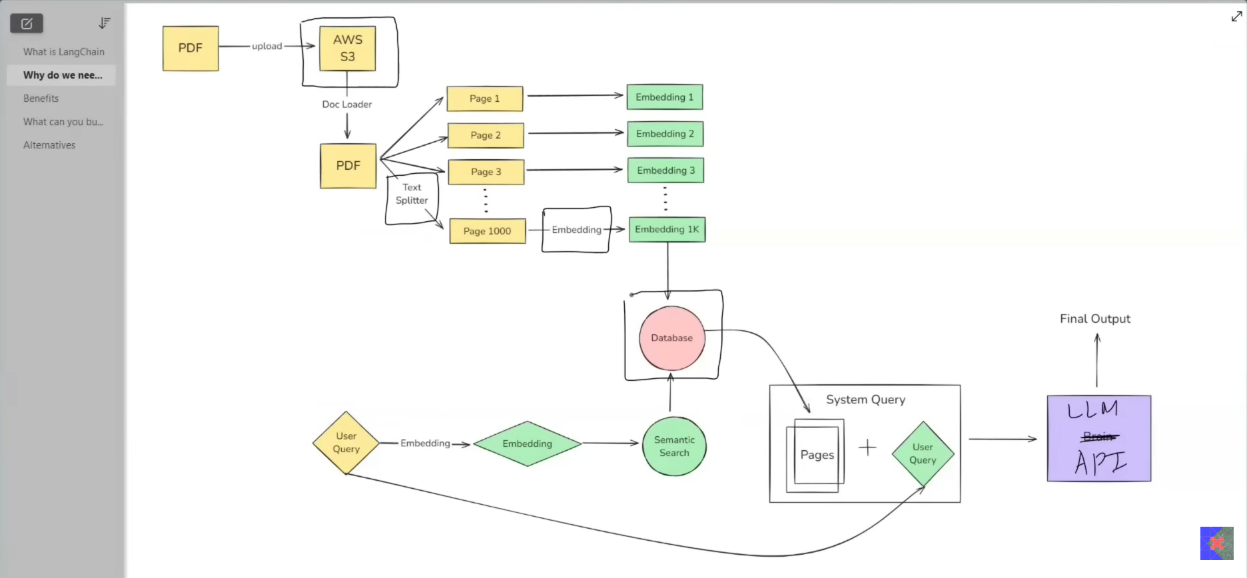

1. Langchain components

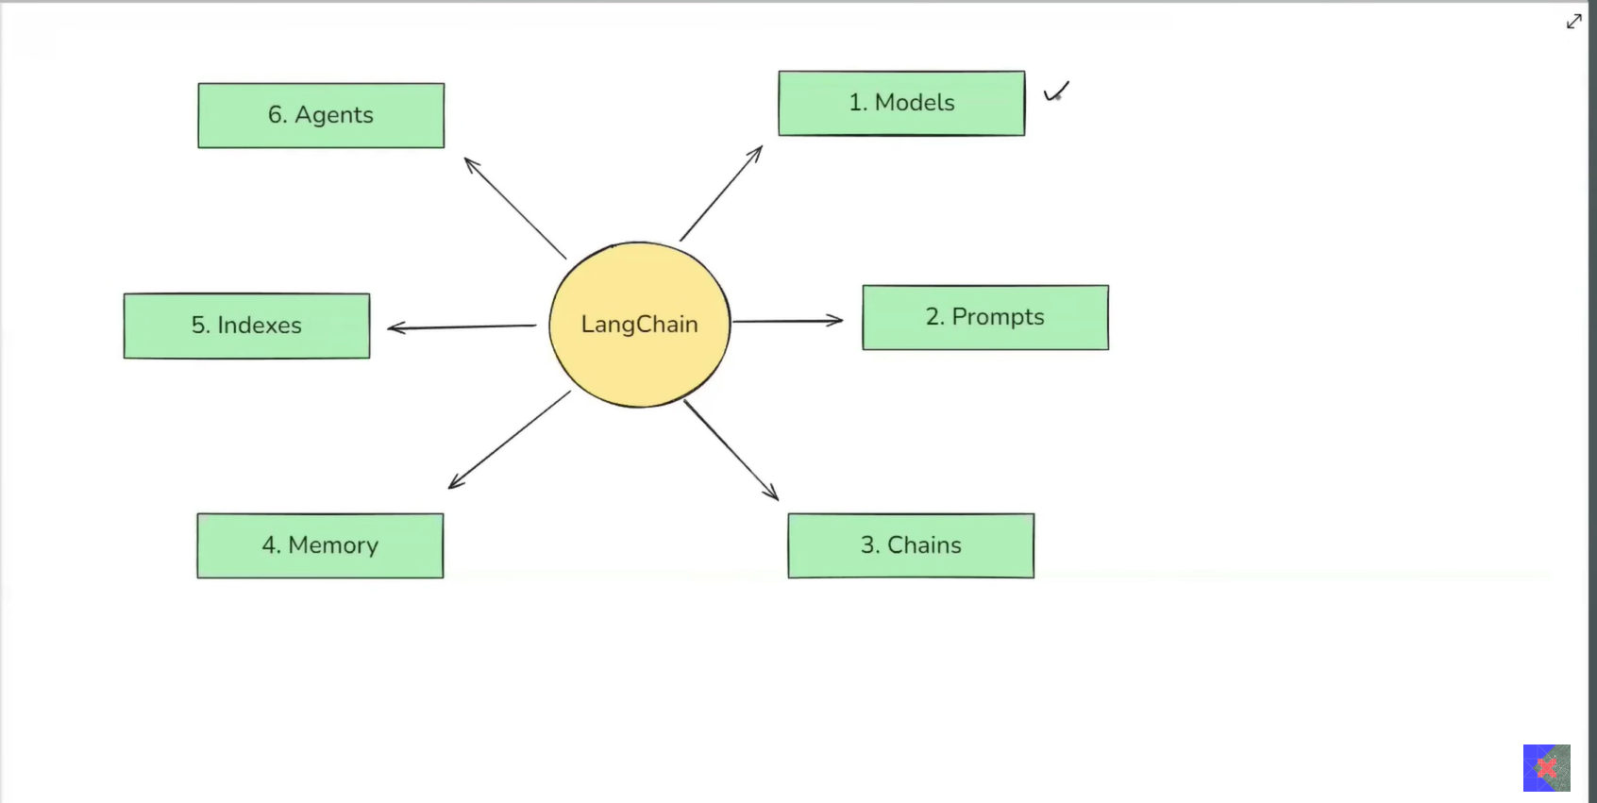

**Models**

